Name: Dunya Polat

Phone number: 818-489-7724

Address: 1001 Monterey Rd, Glendale, CA 91026

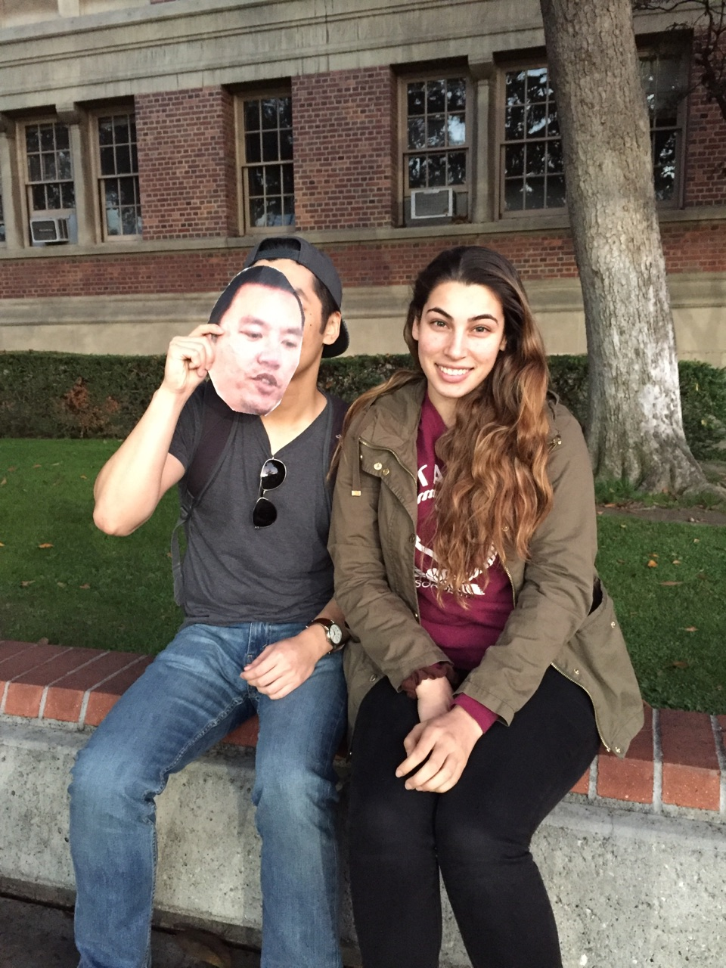

Name: Michelle Grice

Phone number: 949-683-8828

Address: 3067 Paragon, Costa Mesa, CA 92626

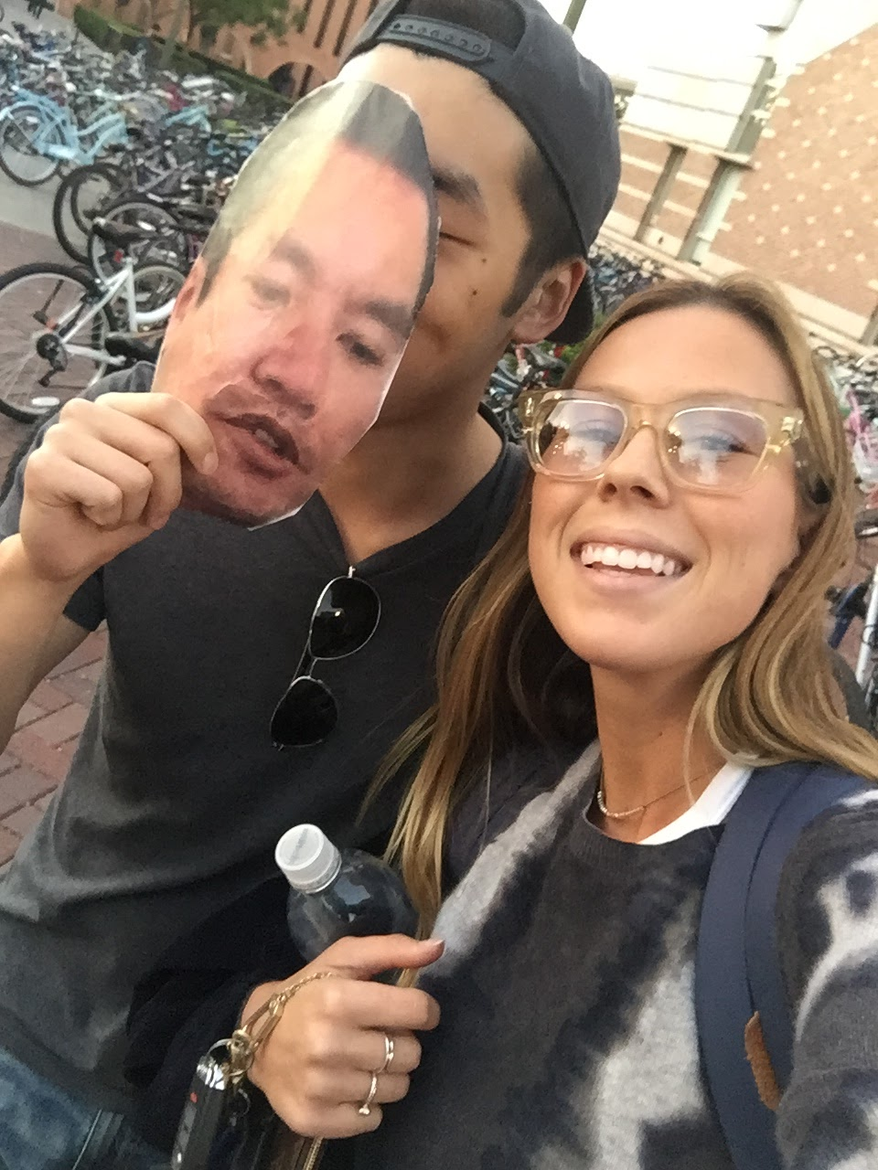

Name: Azin Jindal

Phone Number: 310-993-7182

Address: 159 E Sprice Ave, Inglewood, CA 90301

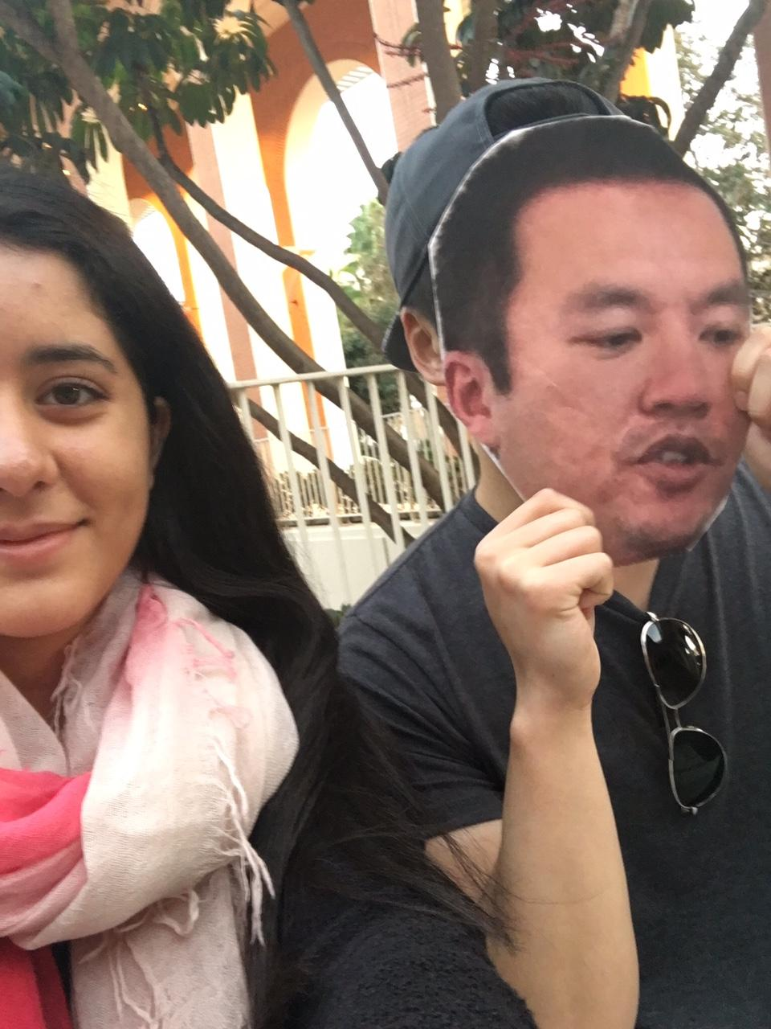

Name: Heykal Prasad

Address: 325 W. Adams Blvd, Los Angeles, CA 90007

Phone Number: 213-618-6417

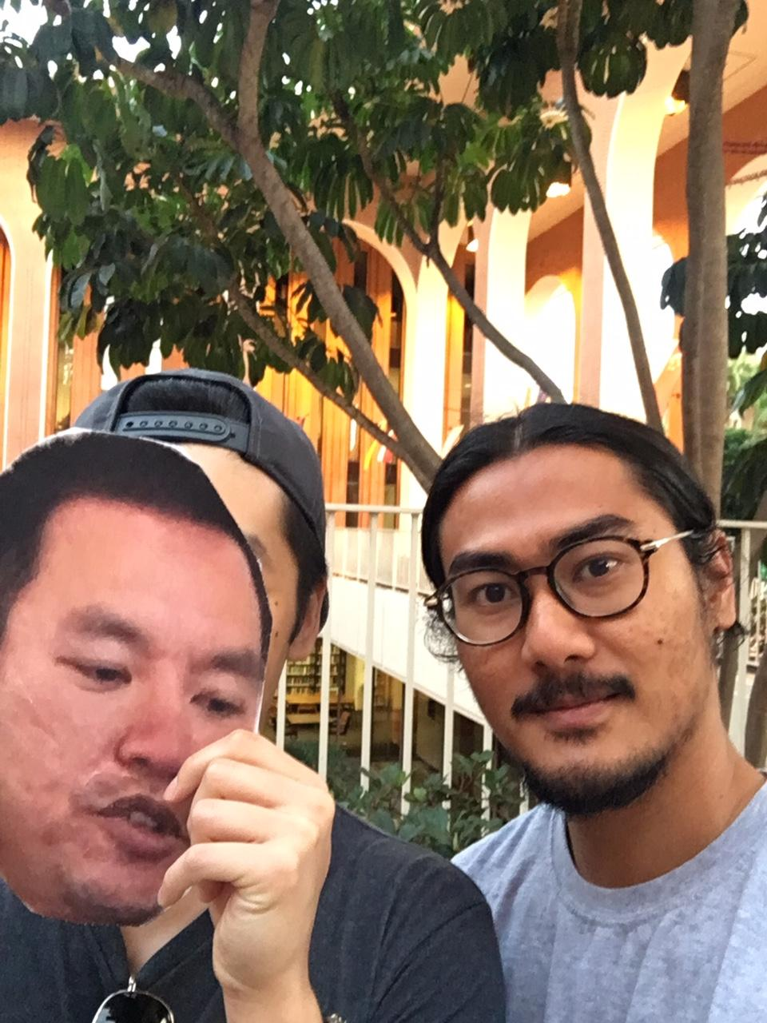

Name: Kayla Gan

Address: 211 S Baldwin Ave, Arcadia, CA 91007

Phone Number: 626-234-9623

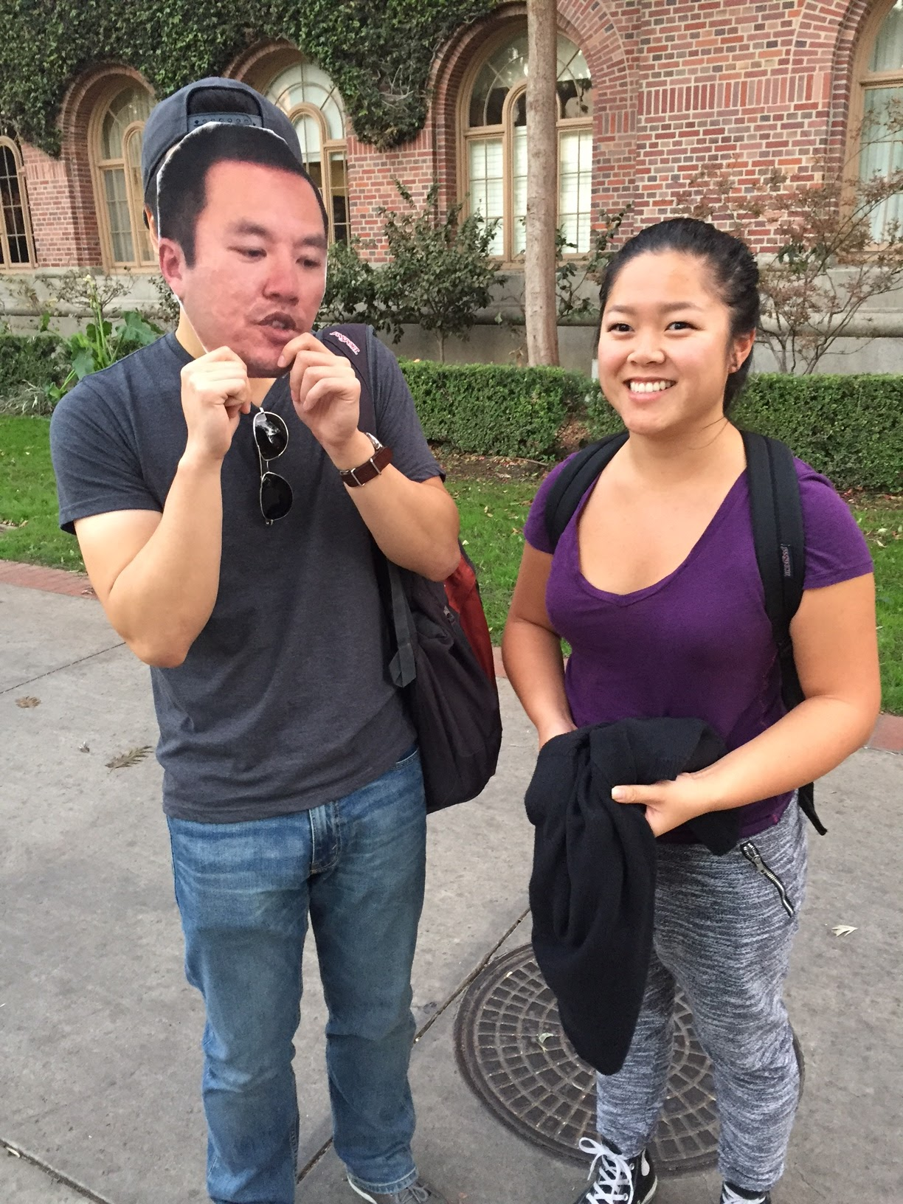

Name: Charles Zhang

Address: 3770 S. Figueroa St, Los Angeles, CA 90007

Phone Number: 213-880-9386

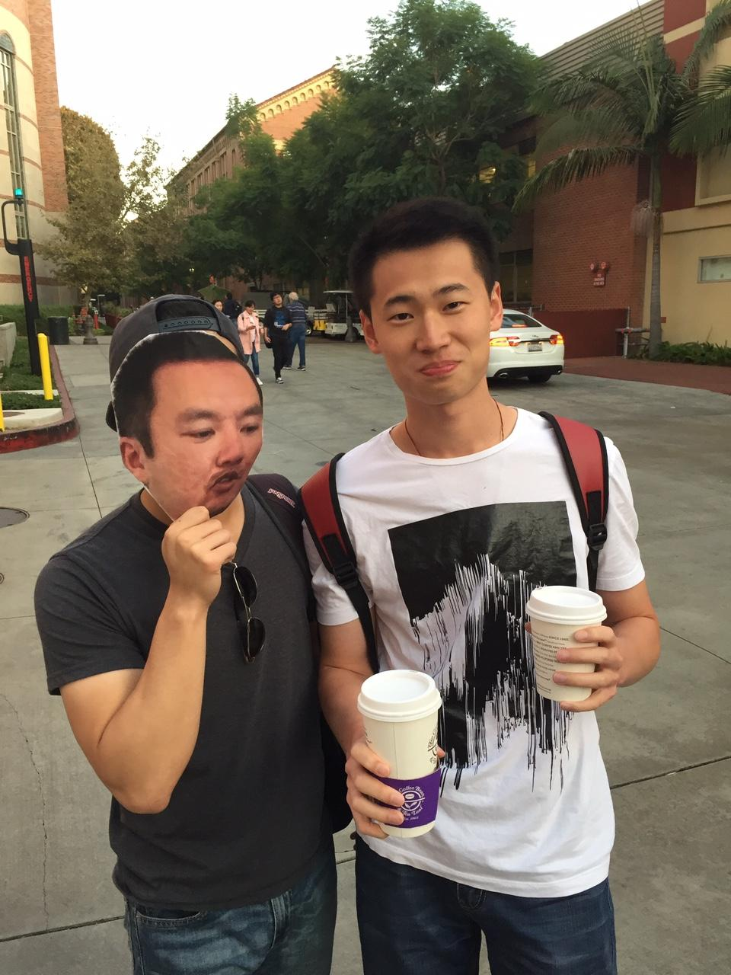

Name: Chotiwat Xi

Address: 1143 W 36th Pl, Los Angeles, CA 90007

Phone Number: 213-357-8903

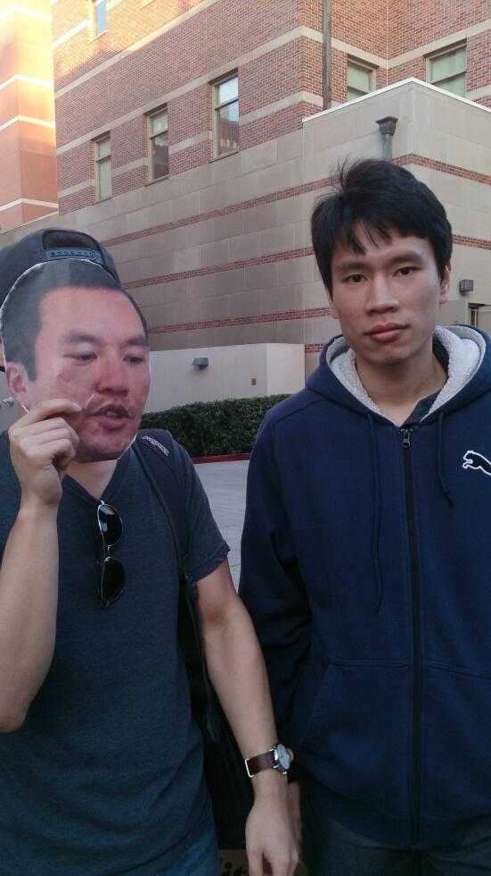

Name: Sean Yee

Address: 1149 W 35th St, Los Angeles, CA 90007

Phone Number: 213-705-3842

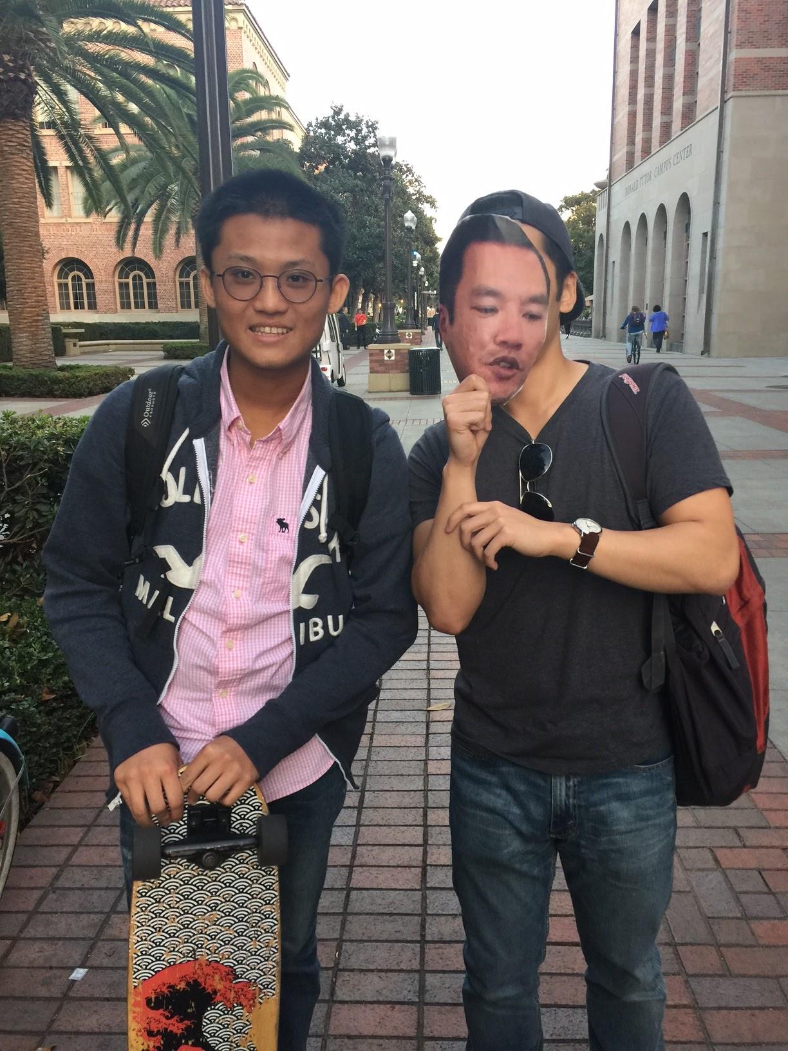

Name: Danielle Lee

Address: 80455 Jasper Park Ave, Indio, CA 92201

Phone Number: 760-219-5209

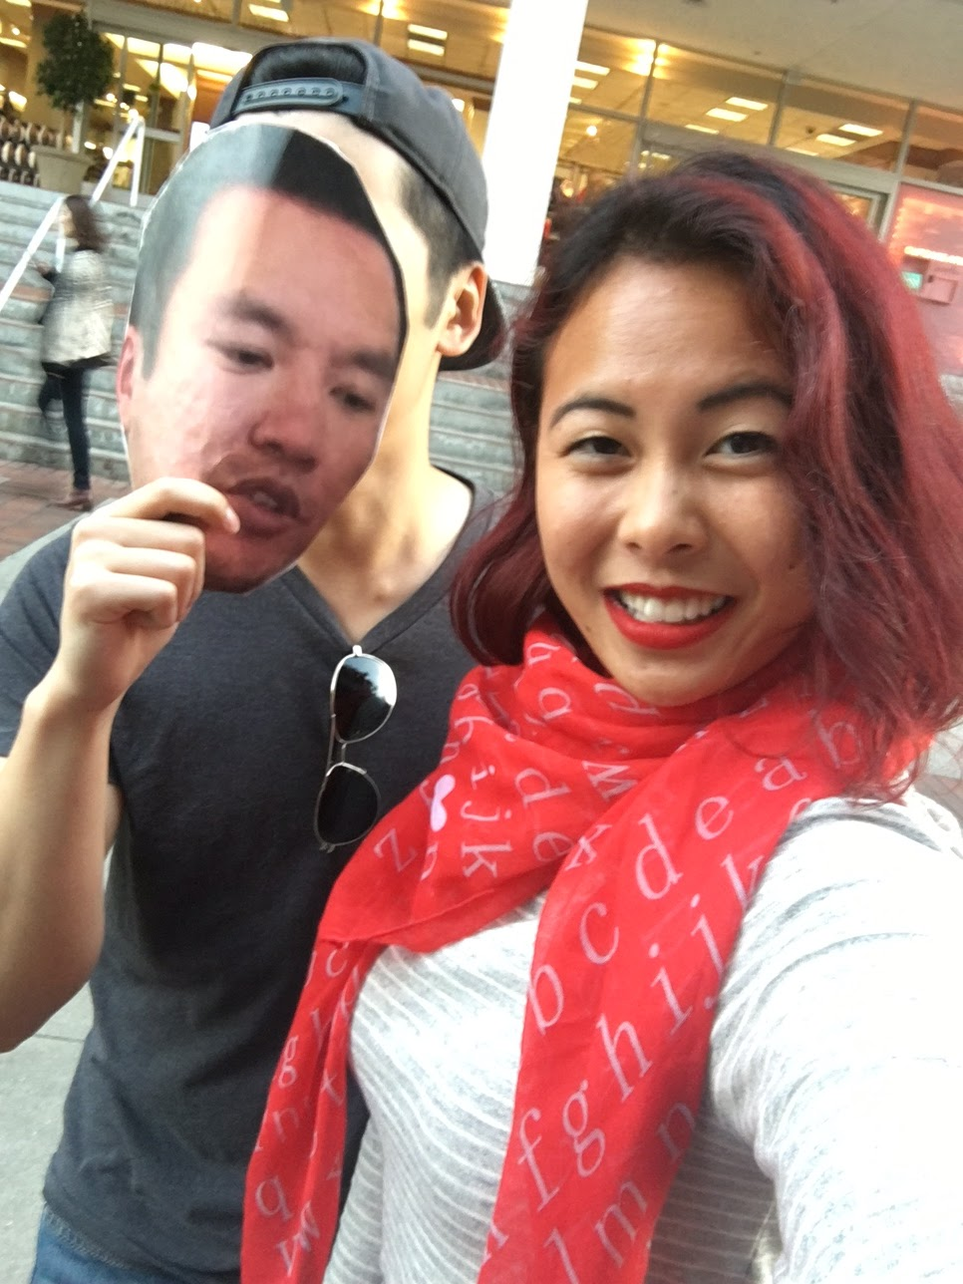

Name: Arpan Badeka

Address: 4319 E 55th St, Maywood, CA 90270

Phone Number: 323-975-0963

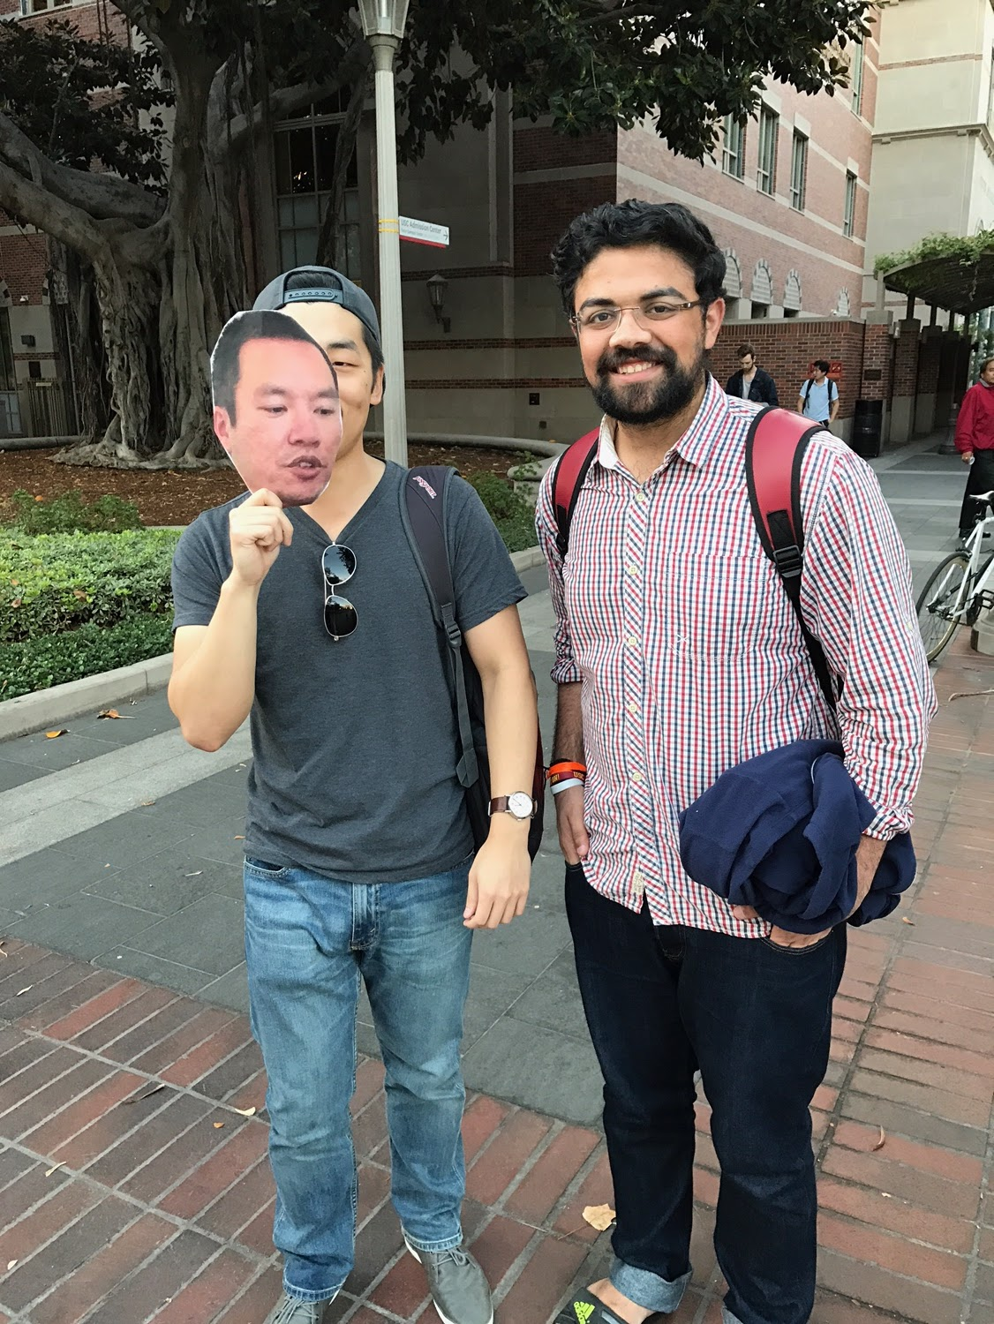

Name: Jayde Kelly

Address: [186 Campbell Street, Darlinghurst, NSW 2010](http://www.realestate.com.au/property-house-nsw-darlinghurst-123986054), Australia

Phone Number: 213-298-7940

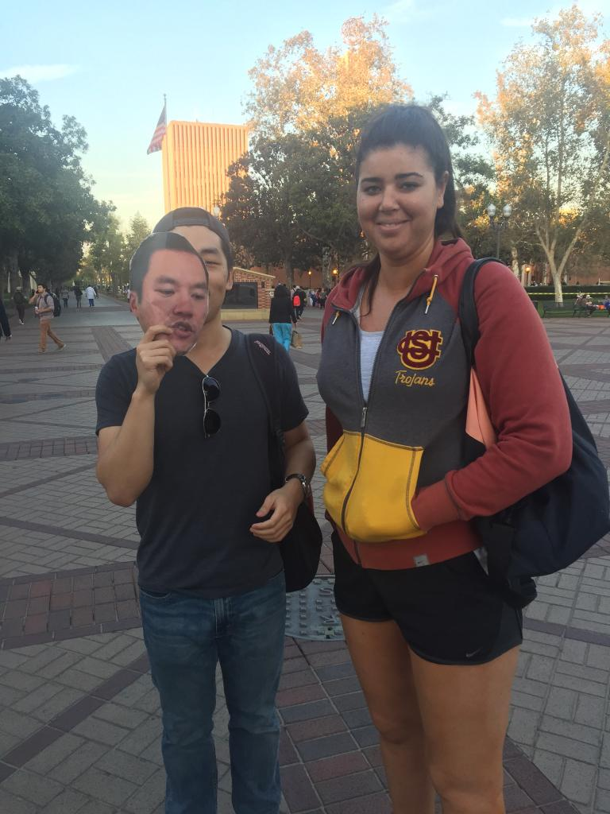

Name: Rachel Mader

Address: 1919 Alameda De Las Pulgas APT 1,San Mateo, CA 94403

Phone Number: 650-388-0331

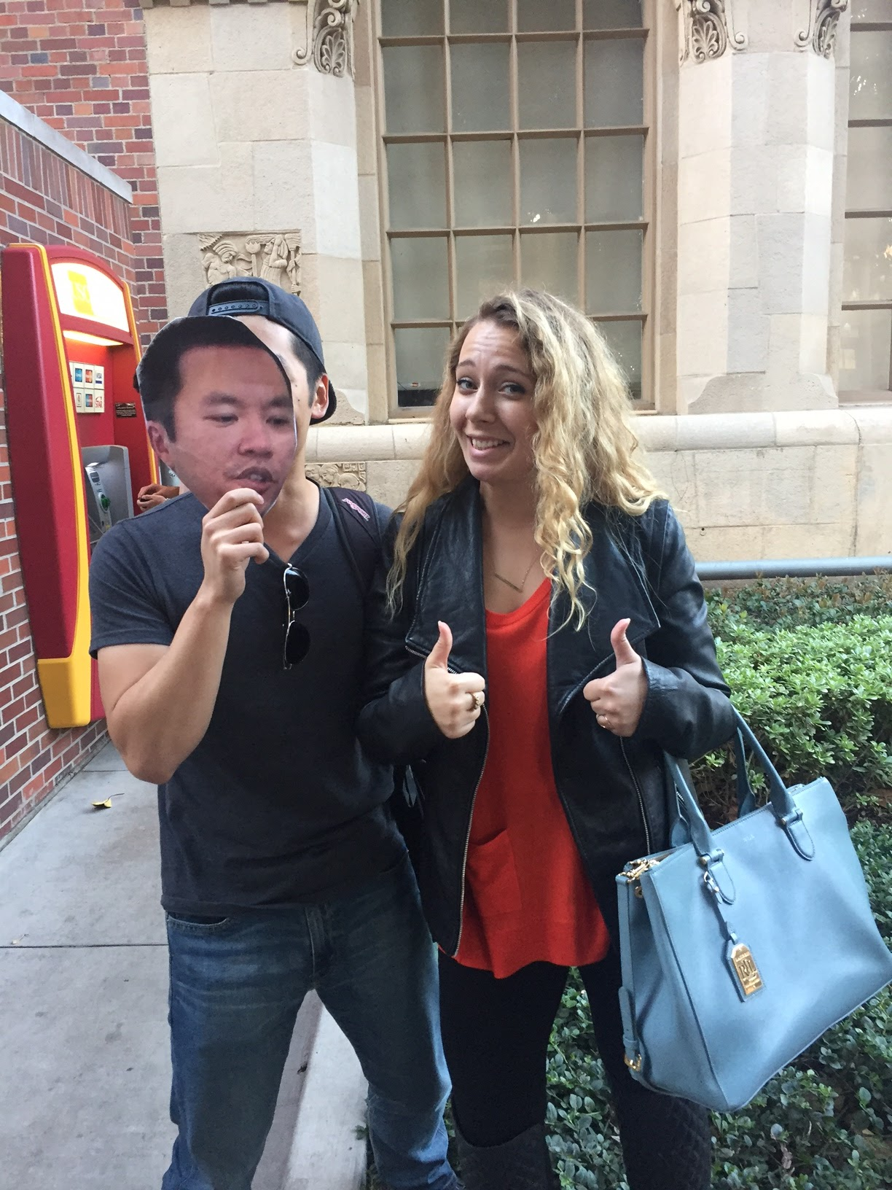

Name: Enoch Han

Address: 5741 Alessandro Ave,Temple City, CA 91780

Phone Number:626-475-7773

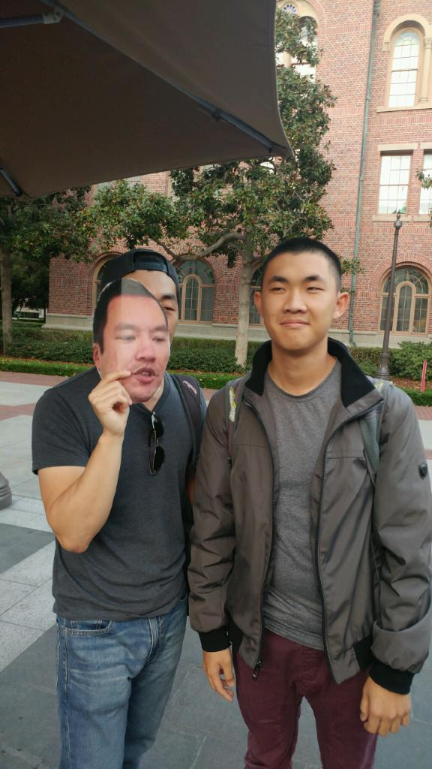

Name: Terrance Choi

Address: 1920 Chantilly Ln,Fullerton, CA 92833

Phone Number: 714-623-8829

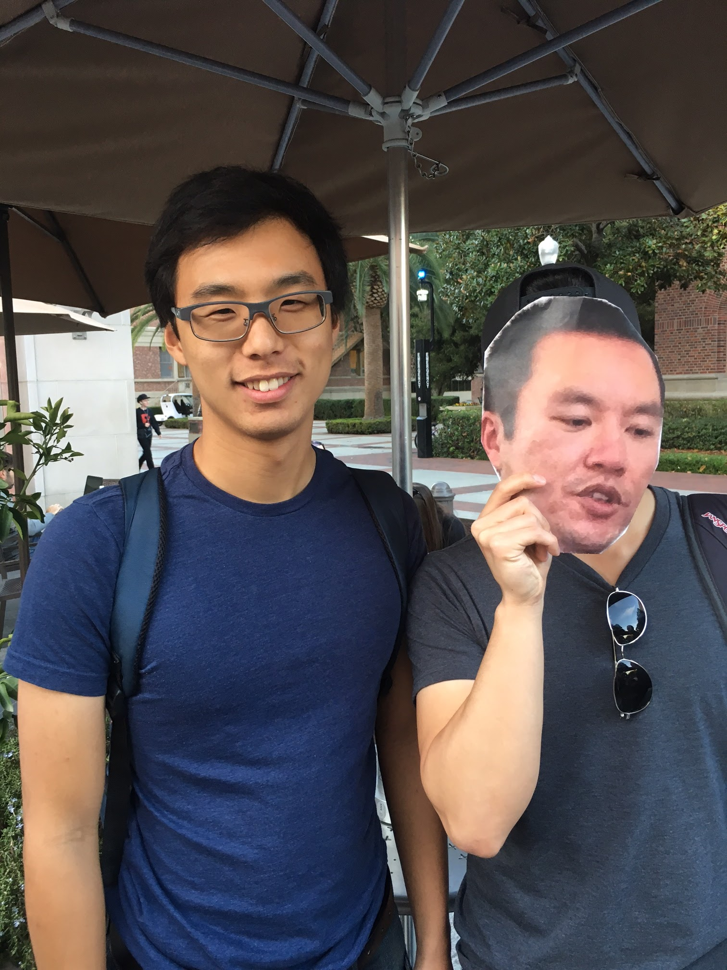

Name: Myrl Showe

Address: 4055 W Rosecrans Ave APT 4,Hawthorne, CA 90250

Phone Number: 310-999-9210

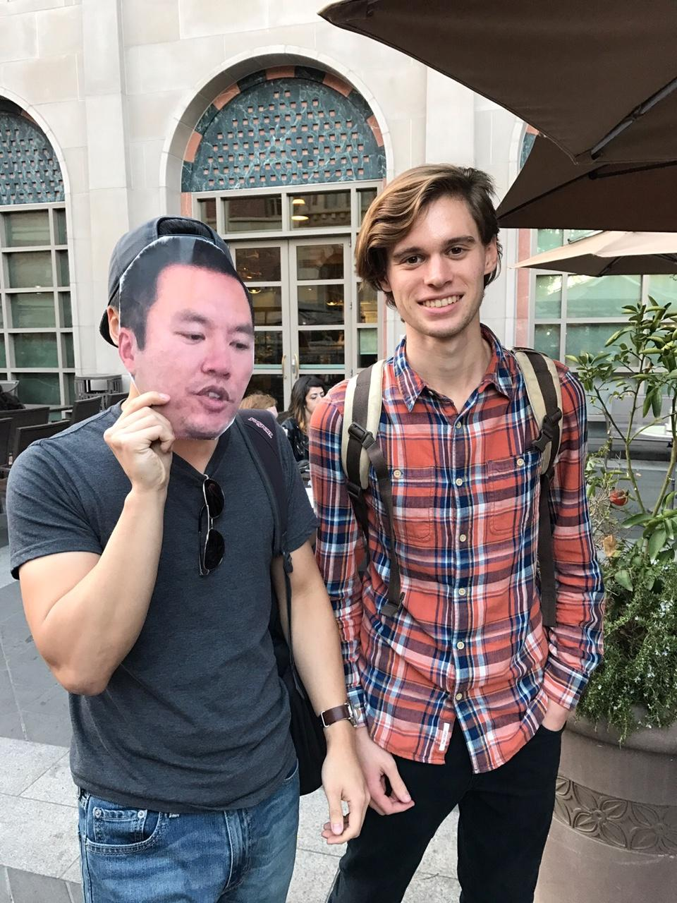

Name: Shujian Zeng

Address: Chongqing South Road 229 Long No.7 Huangpu Qu, Shanghai Shi, Chin 200025

Phone Number: 213-204-0887

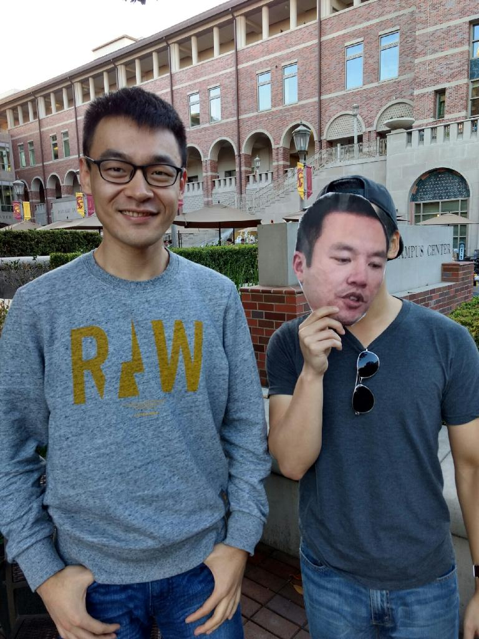

Name: Emon Carlson

Address: 1855 W Virginia Ave,Denver, CO 80223

Phone Number: 303-243-4387

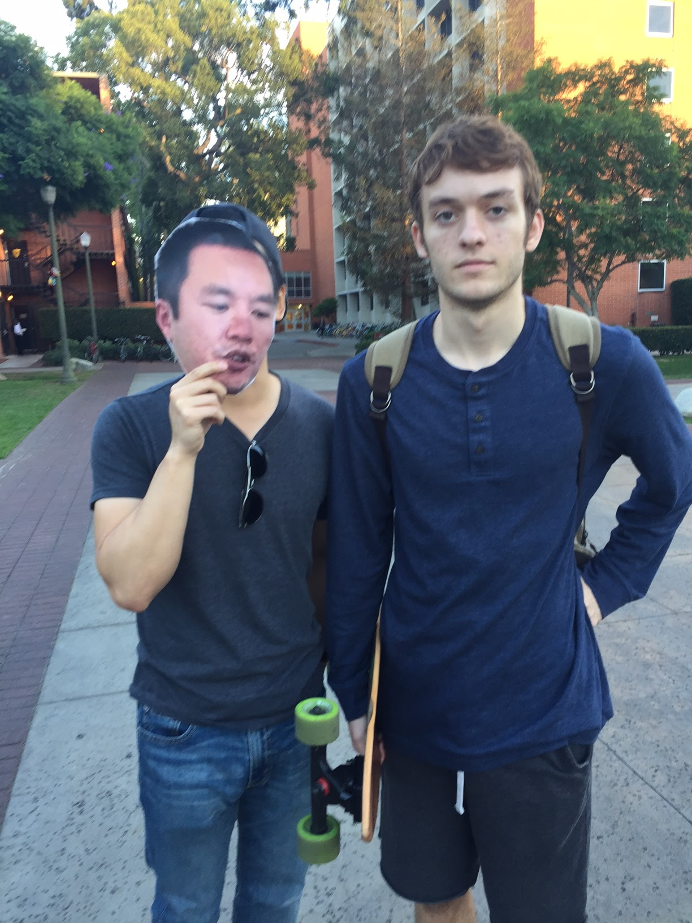

Name: Ziyu Chen

Phone Number: 213-705-4448

Address:1025 W Huntington Dr UNIT M,Arcadia, CA 91007

